**MVP Plan**

**Website** www.istudy.com

**Purpose**

A website where people can tell their history/dreams and ask support to pay their educational costs. The idea is to help people to change their lives through study. The users will be people in need of financial support to start/complete their educational development.

**Target**

Any person that desire to start or conclude their studies

**Database schema**

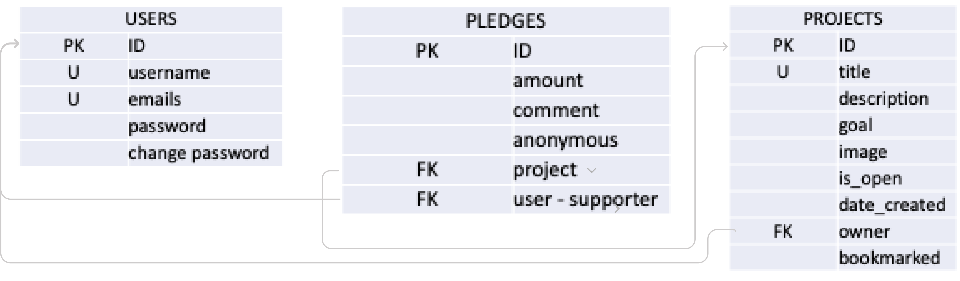

**API specification**